“Science Awareness Week”
under DST Sponsored STUTI Programme
organized at
Aligarh Muslim University

The week long “Science Awareness” programmes held during 22nd - 28th February, 2022 (07 days) at the ALIGARH MUSLIM UNIVERSITY, ALIGARH, INDIA, under the “Synergistic Training program Utilizing the Scientific and Technological Infrastructure (STUTI)” supported by the Department of Science and Technology (DST), Government of India started with the inauguration programme on 22.02.2022 in the Conference Hall of the Physics Department were culminated on 28th February, 2022 i.e., on National Science Day.
The inaugural function of the programme was conducted at the Department of Physics, Aligarh Muslim University, Aligarh at 9.30 AM on 22.02.2022 in the conference hall of the department keeping Covid 19 protocols into mind. The brochure of the week-long programme was also released in the inaugural function. Prof. B. P. Singh, Chairperson, Physics Department and Coordinator, PMU-STUTI programme, highlighted the importance and usefulness of celebrating the Science Awareness Week. Dr. M. Wasi Khan (Coinvestigator) introduced the STUTI initiative of DST to the audience and students and discussed its main features and components. Dr. Jai Prakash (Coinvestigator) conducted the proceedings of inaugural function, convened all the activities undertaken under Science Awareness Week.
The awareness programmes were held as part of “Azadi Ka Amrit Mahotsav” celebrations, and were aimed at arousing and inculcating the scientific temperament among the school children. During this Science Awareness Week, the students of class 11th and 12th (Science Stream) were invited to participate in the programme, not only from the camps but also from nearby places. Under the women empowerment initiative of the Government of India, participation of girl students to the programmes was preferred. During the entire week, each day a new batch of at least 50 students (SCIENCE STREAM) met with prominent faculty working in the leading areas of science and several activities such as Popular science lectures on variety of topics on how science may be used for societal benefits and human welfare, scientific quizzes, elocutions, hands on activity, equipment demonstrations and short film showcasing were conducted.
In the week-long awareness programmes, 392 students (231 boys and 161 girls) from following eight schools participated along with with their teachers;
- Saiyyid Hamid Senior Secondary School (Boys), AMU Aligarh (22.02.2022)
- Senior Secondary School -Girls, AMU Aligarh, (23.02.2022)
- Range Hills Public School, Aligarh (24.02.2022)
- Babu Lal Jain Inter College, Aligarh (25.02.2022)
- Shri Maheshwar Girls Inter College, Aligarh (26.02.2022)
- Mother’s Touch Senior Secondary School, Aligarh, (26.02.2022)
- Angels Public International, Pahasu, Bulandshahar (27.02.2022)
- Naurangi Lal Govt. Inter College, Aligarh. (28.02.2022)
Popular science lectures were delivered by Prof. B. P. Singh, Dr. S. S. Z. Ashraf, Prof. M. Sajjad Athar, Dr. S. M. Afzal, Dr. Sudhir Kumar Gupta, Dr. Jai Prakash and Dr. Dr. Faraz A. Inam. Each day, after attending popular science lecture, students made Science Fun through Science Quizzes. All the participants participated in the quiz competition based on scientific theme. A short Video Film on – “Atomic Energy in India: Glorious past and Resplendent Future” was shown to the students. In this session, elocutions on Science & Technology and innovative ideas of students in science were discussed.
Each day the afternoon session was devoted to “Hands on training activities” through familiarization of Scientific Equipment and Demonstrations as per the directions of government of India. The demonstration of Spectrometers, Microscopes, Liquid Crystals, Telescope, Oscilloscope, Diffractometers etc., were made and students participated in demonstration and hands on training session very enthusiastically. The certificates, Prizes for the winners of quiz competition and Memorabilia were presented to the students.
On the last day students also became the witness of the celebrations of National Science Day-2022 as part of Azadi Ka Amrit Mahotsav. As part of the celebration, Prof. Archana Sharma from CERN, Geneva Switzerland delivered a talk on the topic "Blue Sky Mega Science Research, Corona Virus, Why Should I Care?”
The concluding function of the “Science Awareness” programme was held in the Conferenec Room of the Department of Physics, Aligarh Muslim University, Aligarh at 4.00 PM on 28.02.2022. Prof. S. K. Singh, former Vice Chancellor, Hemwati Nandan Bahuguna Garhwal University, Uttarakhand and former Dean, Faculty of Science, AMU was the Chief Guest and addressed the young minds in the programme. Prof. S. K. Singh presented his valuable views on the occasion. He suggested to the students about how to go about making the choice in their career.
The programmes conducted during the entire week were well appreciated by all students during the feedback sessions. They shared their experience and mentioned that they are carrying one of the memorable experiences of their life. The students also expressed that such programmes should be arranged on a regular basis so that young school students may get acquainted of facilities available in their nearby institutes and discuss progress in science and its relevance to society.

SOME PHOTOGRAPHS below;
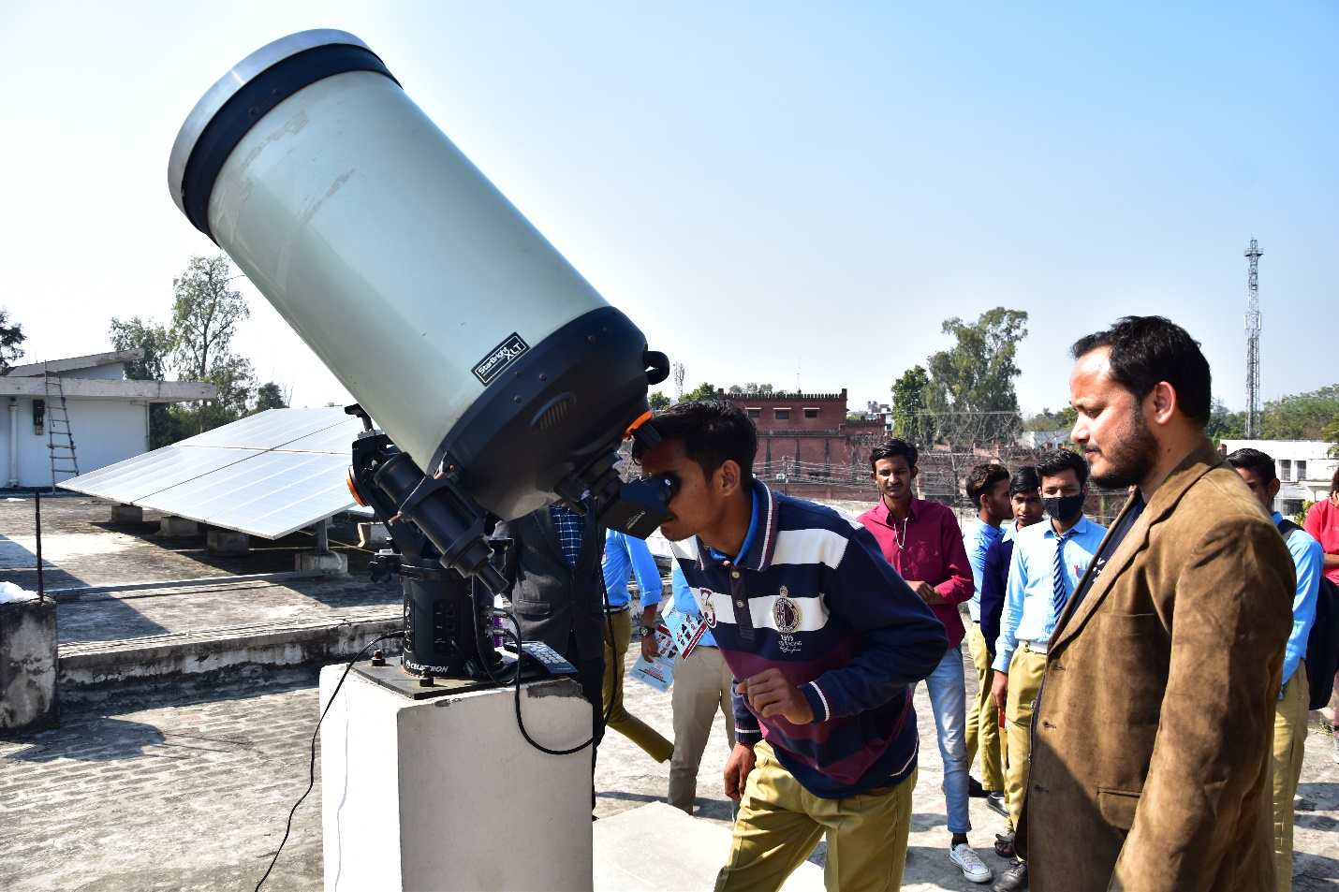
Students having view of Sunspots using Telescope
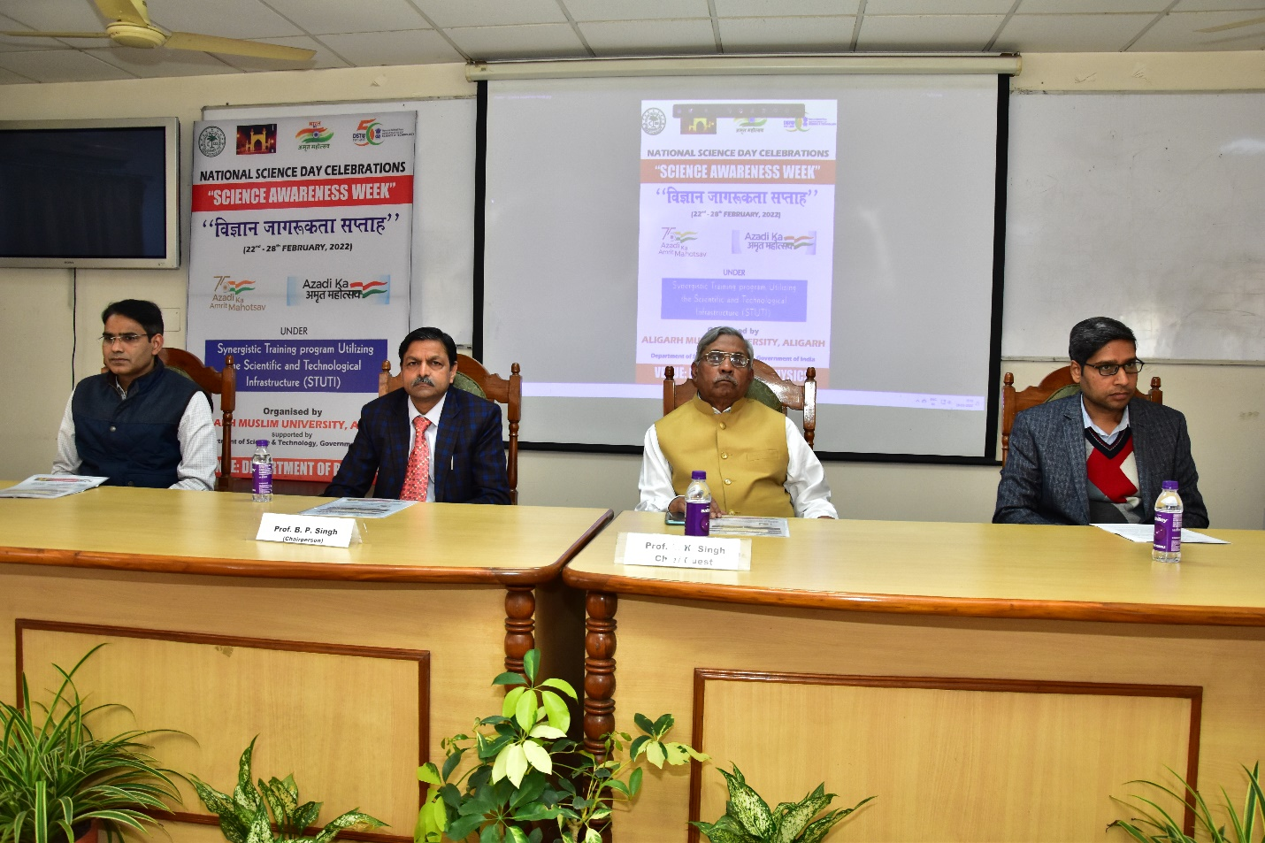
Concluding Session: (R to L) Dr. Wasi Khan (Co-investigator), Prof. B.P. Singh (Coordinator-PMU STUTI, AMU Aligarh) Prof. S.K. Singh (Chief Guest, Ex-Vice Chancellor, HNB Garhwal University) an dDr. Jai Prakash (Co-invesitigator)
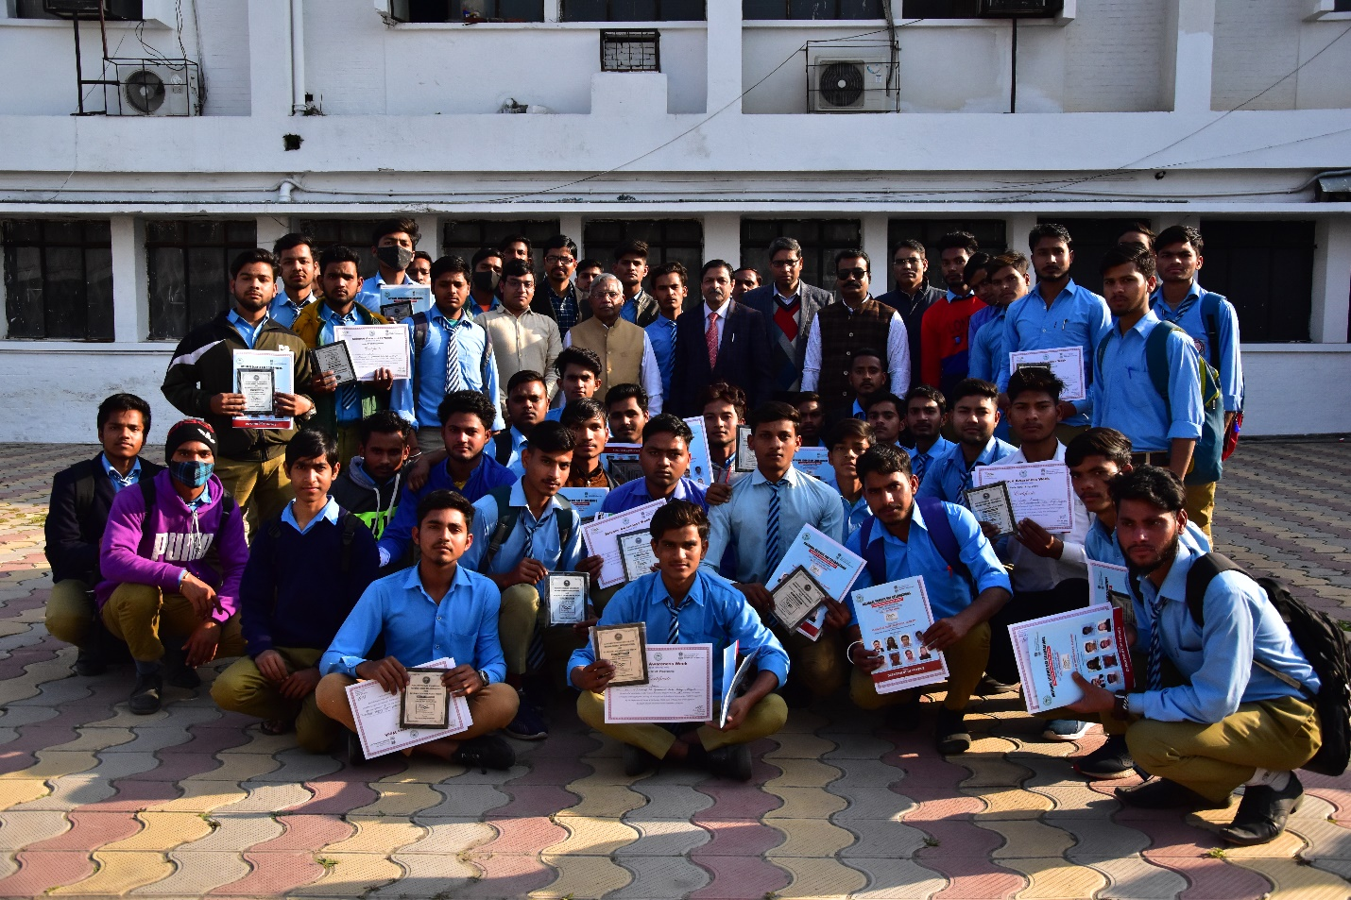
Photograph: Students of NL Govt. Inter College Aligarh

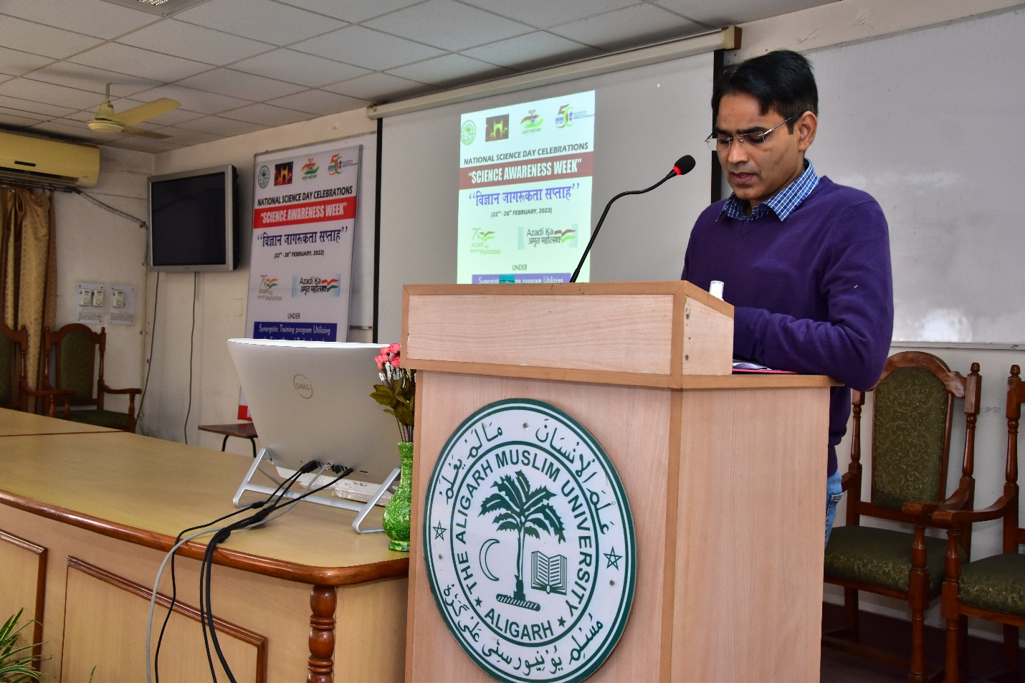
Dr Wasi Khan (Co-investigator) introducing STUTI Progarmme to paticipants

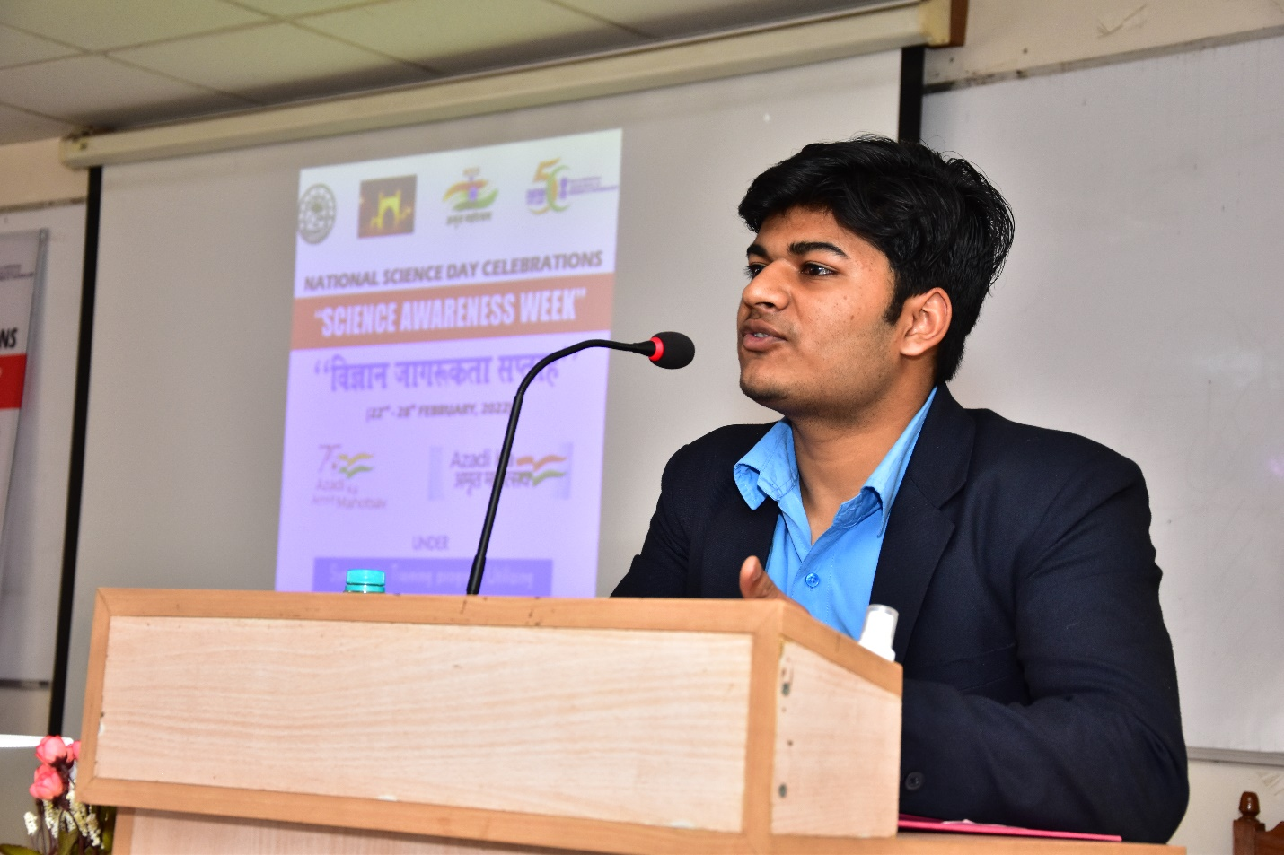
One of the students presenting his views about the programme

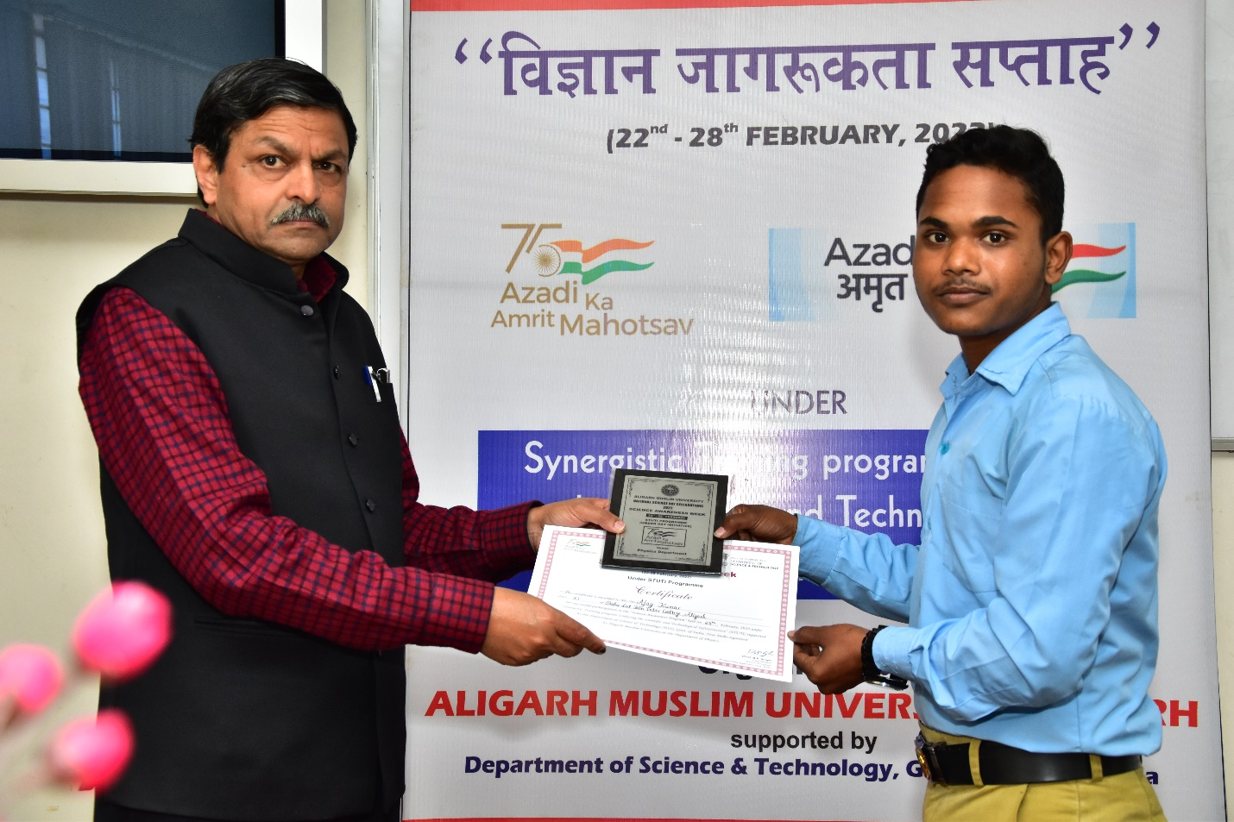
Certificate and Memorabilia presentation to one of the students by Prof. B. P. Singh (Coordinator-STUTI-AMU)

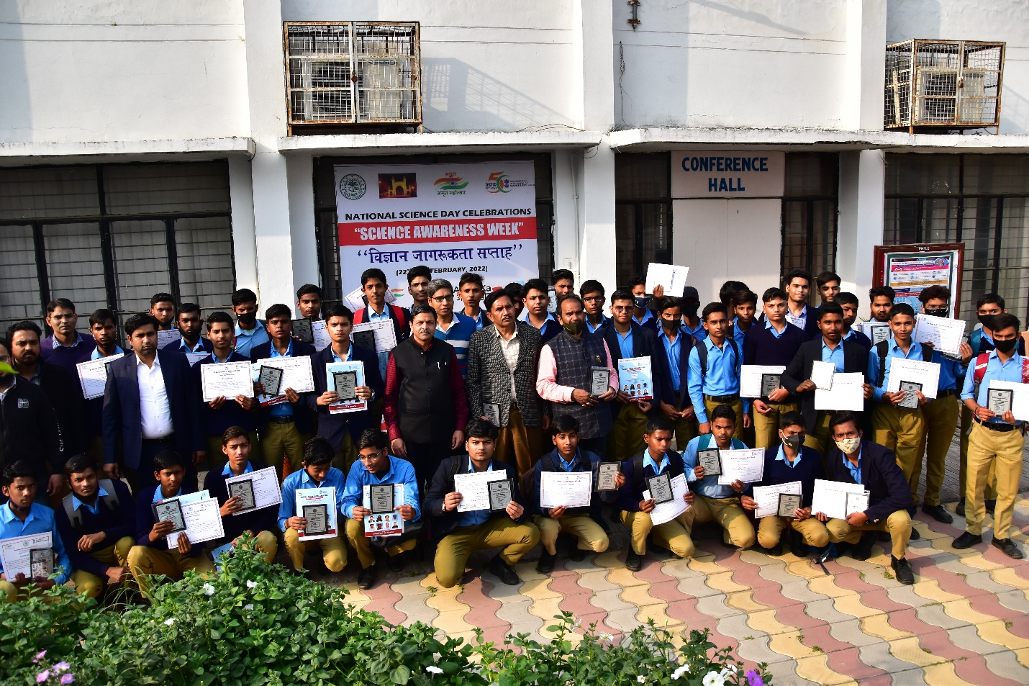
Students of Babu Lal Jain Inter College, Aligarh
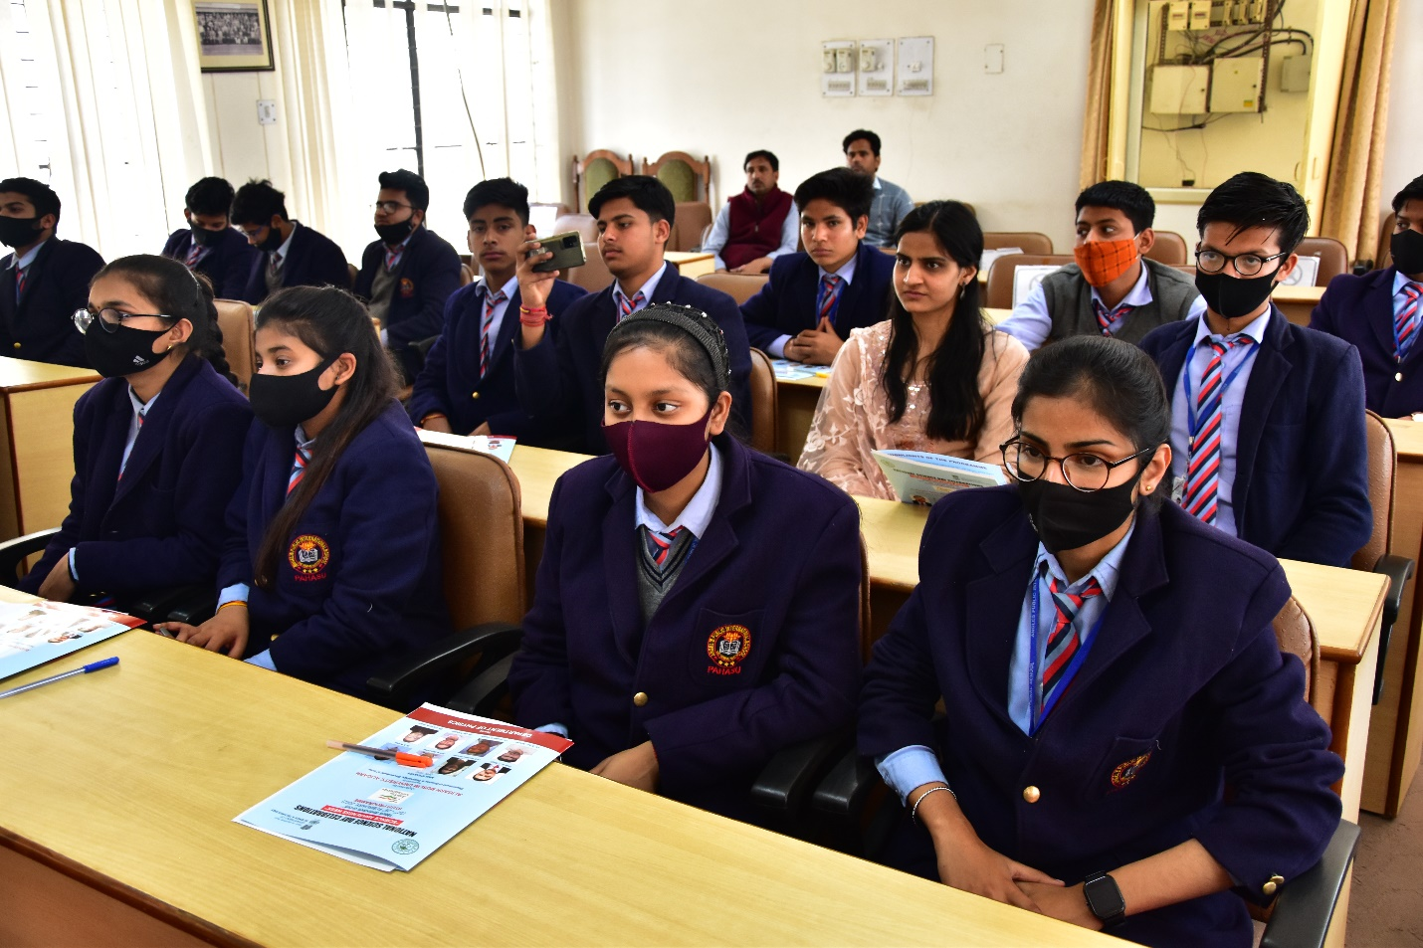
Studenst of Angels Public School, Pahasu, Bulandshahr, attending the Popular Talk

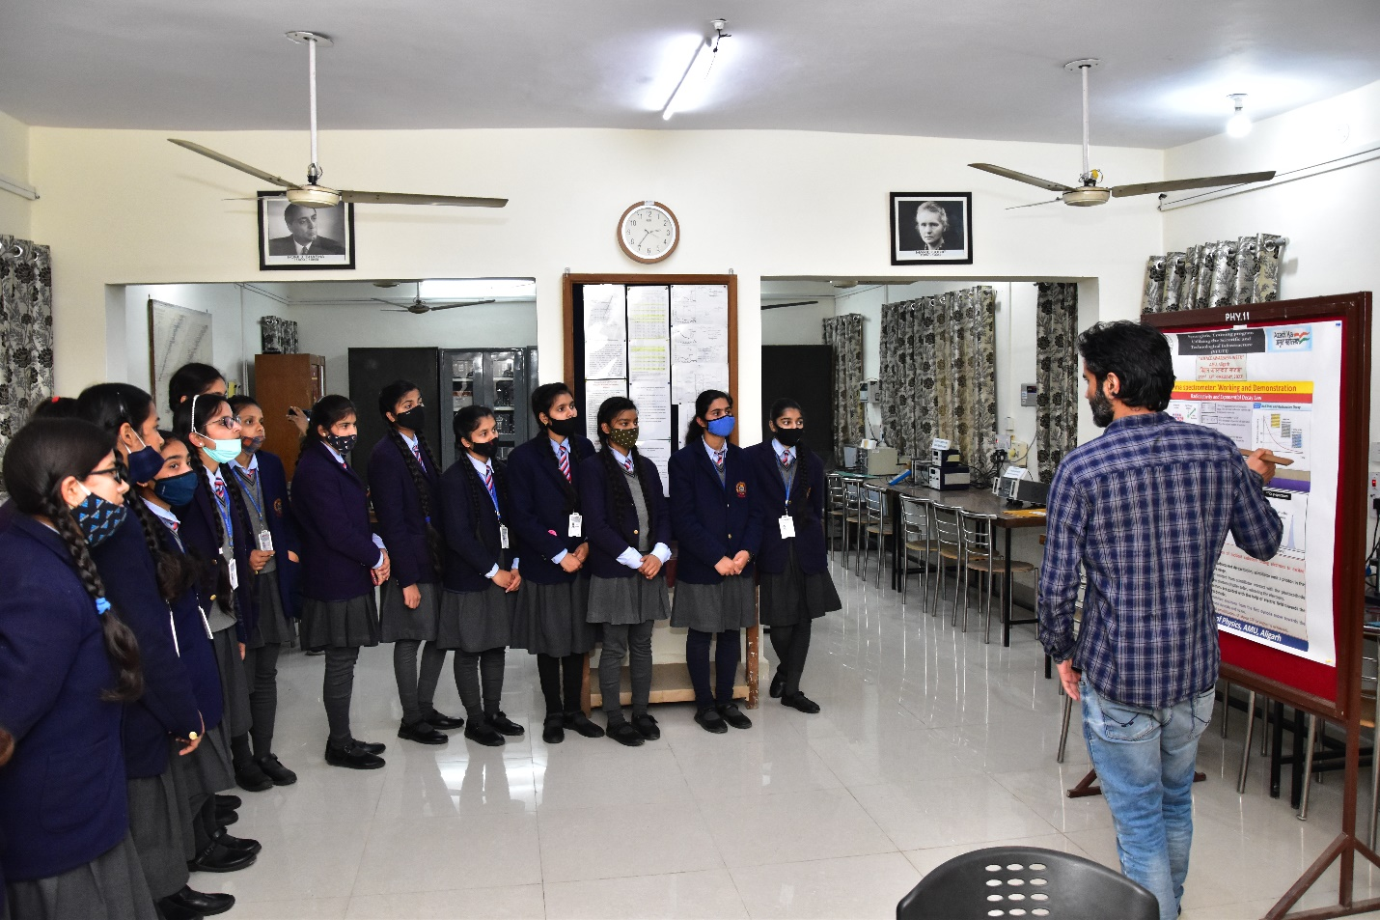
Students of Angles School, Pahasu, Bulandshahar, understanding the working of spectrometers
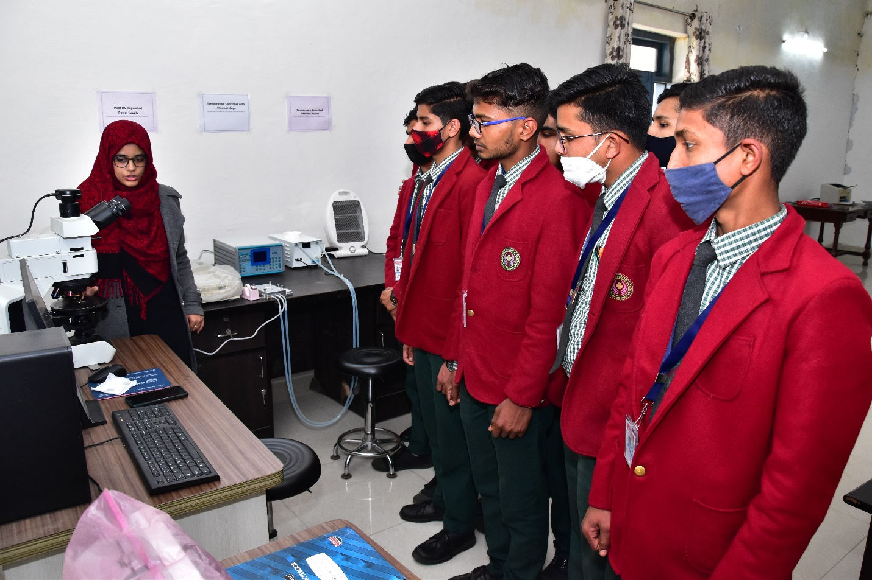
Students of range Hills Public School, Aligarh

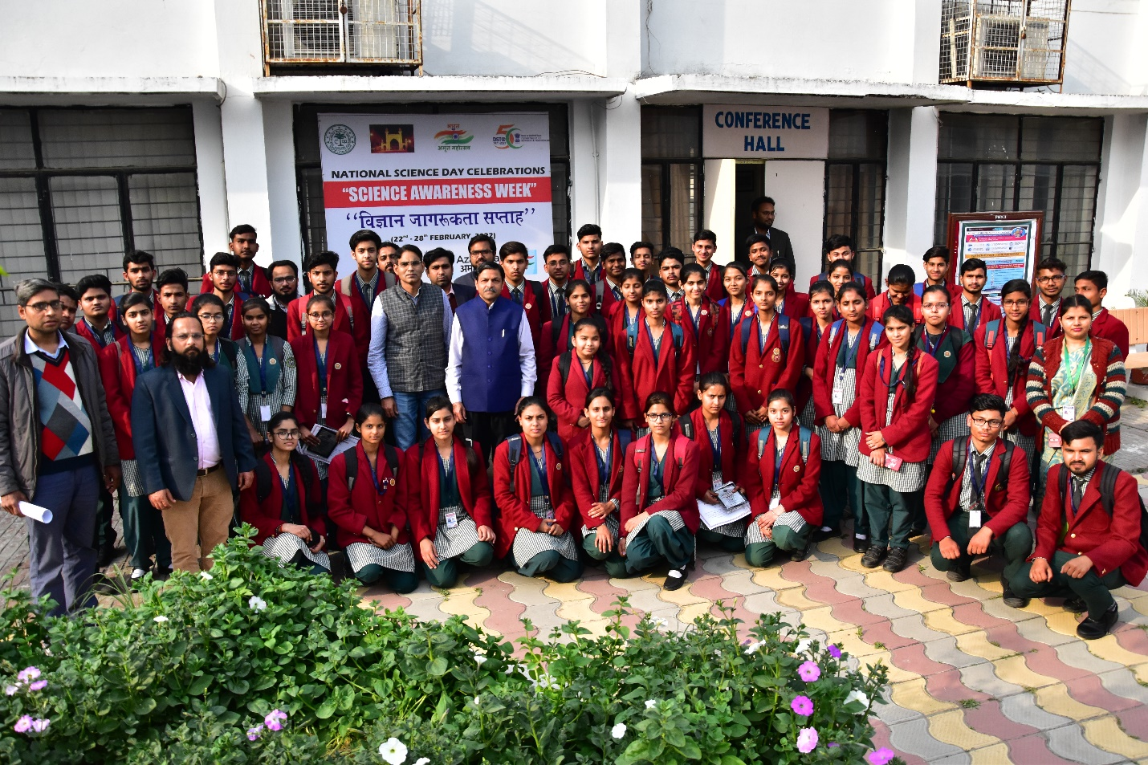
Students of range Hills Public School, Aligarh

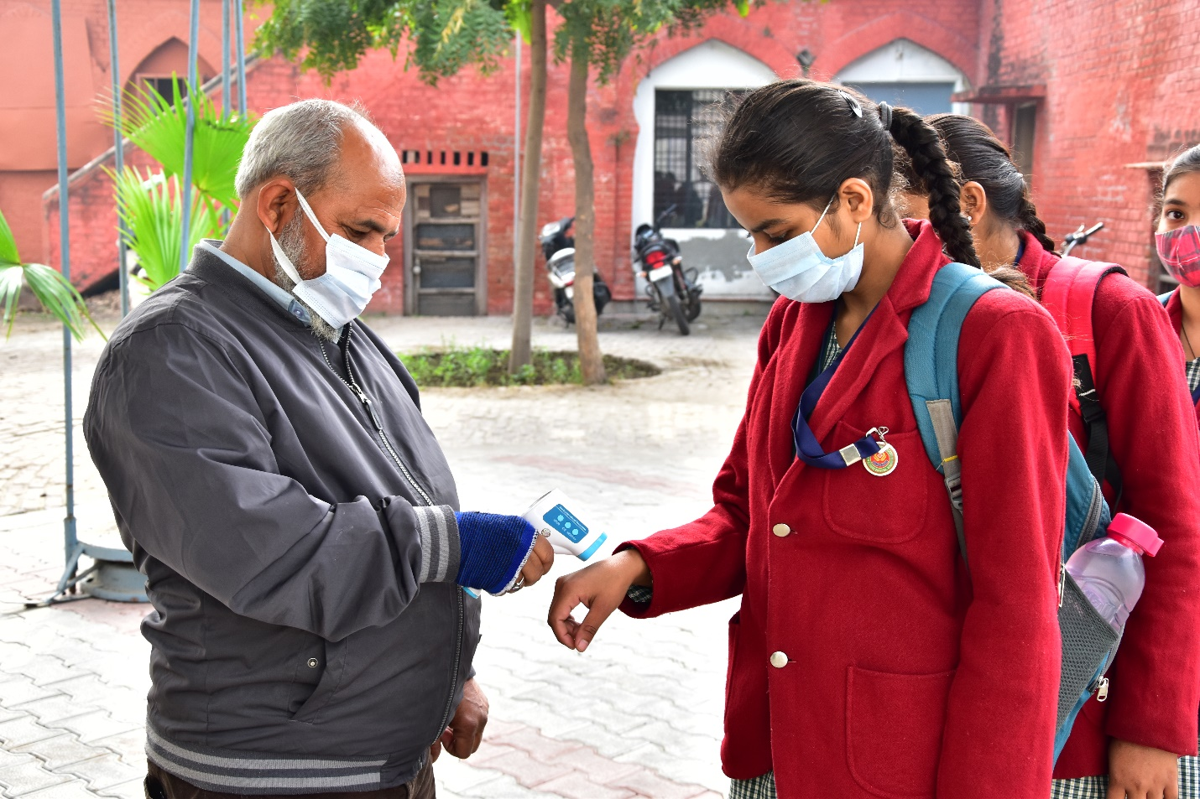
Each Student was allowed after proper Thermal Scanning

